Relationship between classes in Java (explained in plain English)
In Java, classes don’t live alone.
They connect with each other.
This connection is called a relationship.
Mainly, Java uses two very important relationships:

1️⃣ IS-A Relationship (Inheritance)
What does IS-A mean in real life?
When we say:
Dog is an Animal
We are saying:
- Every dog is an animal
- Dog belongs to the animal family
This same idea is used in Java.

How Java understands IS-A
In Java, IS-A is created using inheritance.
That means:
- One class inherits another class
- Child class gets properties and methods of parent class
Keyword used:
extends

Simple example
class Animal {
void eat() {
System.out.println("Animal eats");
}
}

class Dog extends Animal {
void bark() {
System.out.println("Dog barks");
}
}
Now read this slowly 👇
- Dog extends Animal
- So Dog IS-A Animal
- Dog can:
  - eat() → inherited from Animal
  - bark() → its own behavior
👉 Dog automatically becomes an Animal

Why IS-A is useful
- Code reuse (no need to write same code again)
- Logical hierarchy
- Polymorphism works only because of IS-A
📌 Golden thought
If you can naturally say
“A ___ is a ___”
then IS-A relationship fits.

2. Has – Relationship
// we will dicuss on it in further sessions in detail

2️⃣ Inheritance
Inheritance is the process by which one class acquires the properties (variables) and behavior (methods) of another class.
Important Naming Terms
class Child extends Parent
- Child class → subclass / derived class
- Parent class → superclass / base class

3️⃣ Code Reusability
Code reusability is achieved mainly through inheritance (IS-A relationship) and composition (HAS-A relationship).

4️⃣ Single Level Inheritance
Concept
- One child class extends one parent class.
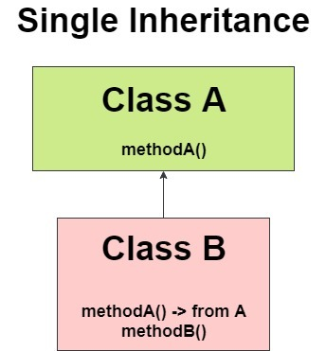

Eg: Inheritance_Demo_Eg1

5️⃣ Object Class – Very Important (Expanded)
Correct Points
- Object class is present in java.lang package
- It is the root class of Java
- Every class in Java:
  - Directly OR
  - Indirectly
inherits from Object
Common Object class methods:
- toString()
- equals()
- hashCode()
- getClass()
- clone()
- finalize()

6️⃣ Multilevel Inheritance
Concept
Multilevel inheritance in Java is a type of inheritance where a class is derived from another class that is also derived from another class, forming a chain of inheritance in which each subclass inherits the properties and methods of all its parent classes.

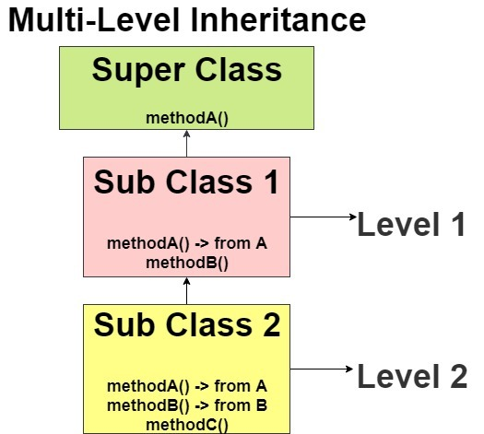

Eg: Multilevel_Inheritance_Eg2

7️⃣ Hierarchical Inheritance
Hierarchical inheritance in Java means one parent class is extended by multiple child classes.

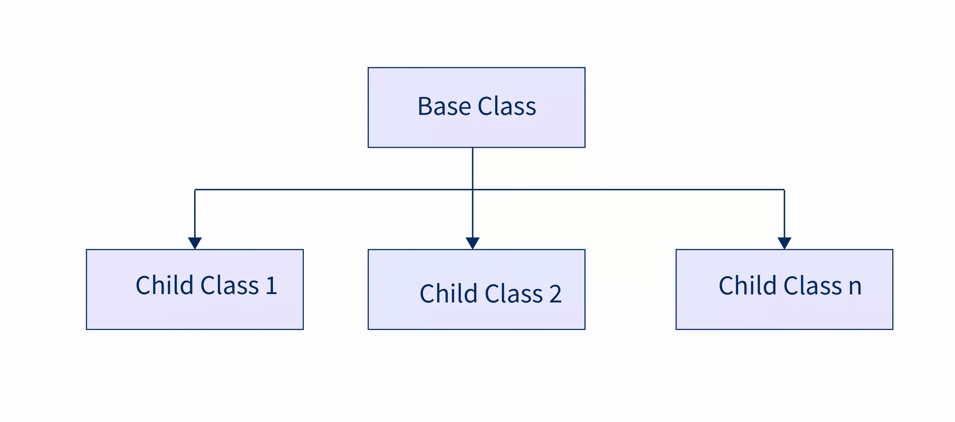
Eg: Hierarchical_Inheritance_Eg3

🔹 Definition of Hybrid Inheritance (Java-correct)
Hybrid inheritance is an inheritance structure that combines two or more types of inheritance (such as single, multilevel, or hierarchical) in a single design.
In Java:
- Hybrid inheritance is allowed with classes only when no multiple inheritance is involved.
- If hybrid inheritance requires multiple inheritance, it cannot be implemented using classes and must be implemented using interfaces.

📌 Clear Rule Table (No Confusion)
Hybrid Structure | Multiple Inheritance Present? | Allowed with Classes? | Allowed with Interfaces?
Single + Hierarchical | ❌ No | ✅ Yes | ✅ Yes
Multilevel + Hierarchical | ❌ No | ✅ Yes | ✅ Yes
Diamond-shaped hybrid | ✅ Yes | ❌ No | ✅ Yes
Any hybrid needing 2 parents | ✅ Yes | ❌ No | ✅ Yes

Different combinations of hybrid inheritance:

Java allows multiple inheritance ONLY when additional parents are interfaces.
Java never allows a class to have more than one class parent.
🟢 Case 1: 2 Classes → 1 Class (❌ NOT allowed)
class A { }
class B { }

class D extends A, B { } // ❌ NOT allowed
❌ Reason:
- Ambiguity
- Diamond problem
- JVM confusion
🚫 This is multiple inheritance using classes → Java forbids it

🟢 Case 2: 1 Class + 1 Interface → 1 Class (✅ Allowed)
class A { }

interface B { }

class D extends A implements B { } // ✅ Allowed
✔️ One class parent
✔️ One interface parent
✔️ Multiple inheritance achieved safely
👉 This is what your code is doing

🟢 Case 3: 1 Class + Multiple Interfaces → 1 Class (✅ Allowed)
class A { }

interface B { }
interface C { }

class D extends A implements B, C { } // ✅ Allowed
✔️ One class
✔️ Many interfaces
✔️ Very common in real projects (Spring, Java APIs)

🟢 Case 4: 2 or More Interfaces → 1 Class (✅ Allowed)
interface A { }
interface B { }

class D implements A, B { } // ✅ Allowed
✔️ No class parent
✔️ Only interfaces
✔️ Pure multiple inheritance

🟢 Case 5: Interfaces extending Interfaces (✅ Allowed)
interface A { }
interface B { }

interface C extends A, B { } // ✅ Allowed
✔️ Interfaces can extend multiple interfaces
✔️ This is multiple inheritance at interface level

🟢 Case 6: Class extending Interface (❌ NOT allowed)
interface A { }

class B extends A { } // ❌ NOT allowed
❌ Wrong keyword
❌ Classes use implements, not extends

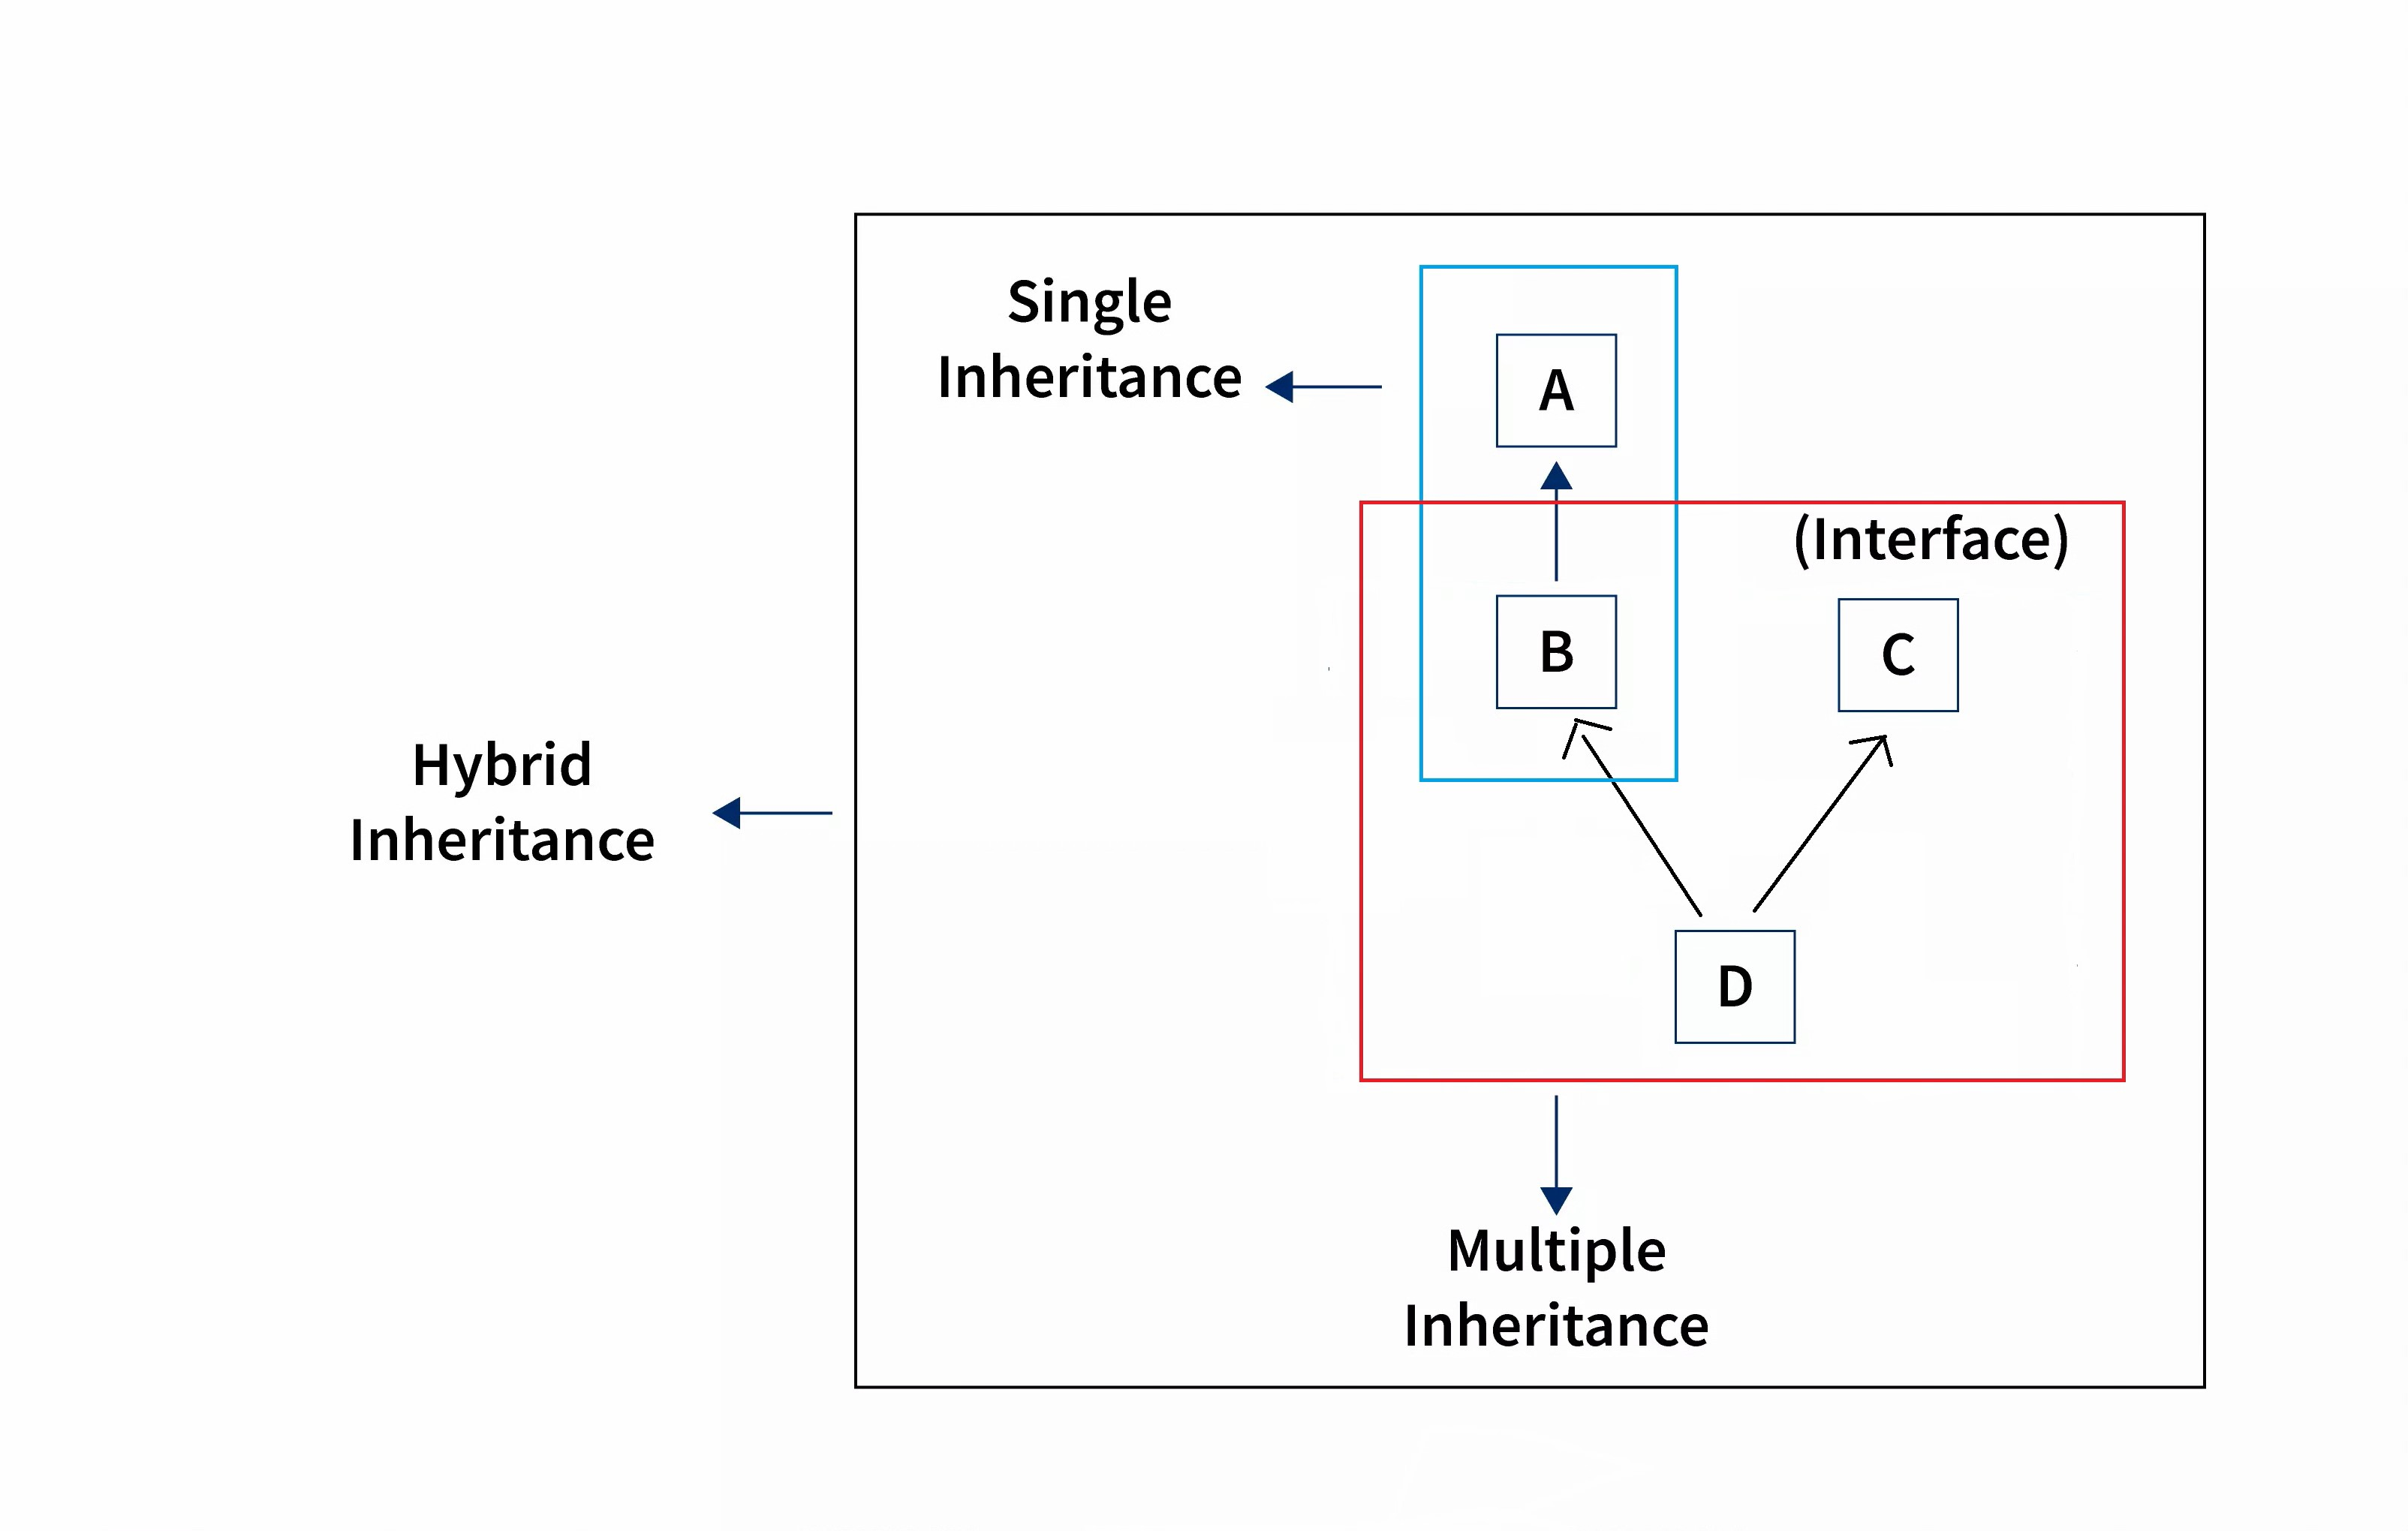
Eg : Hybrid_Inheritance_Eg1

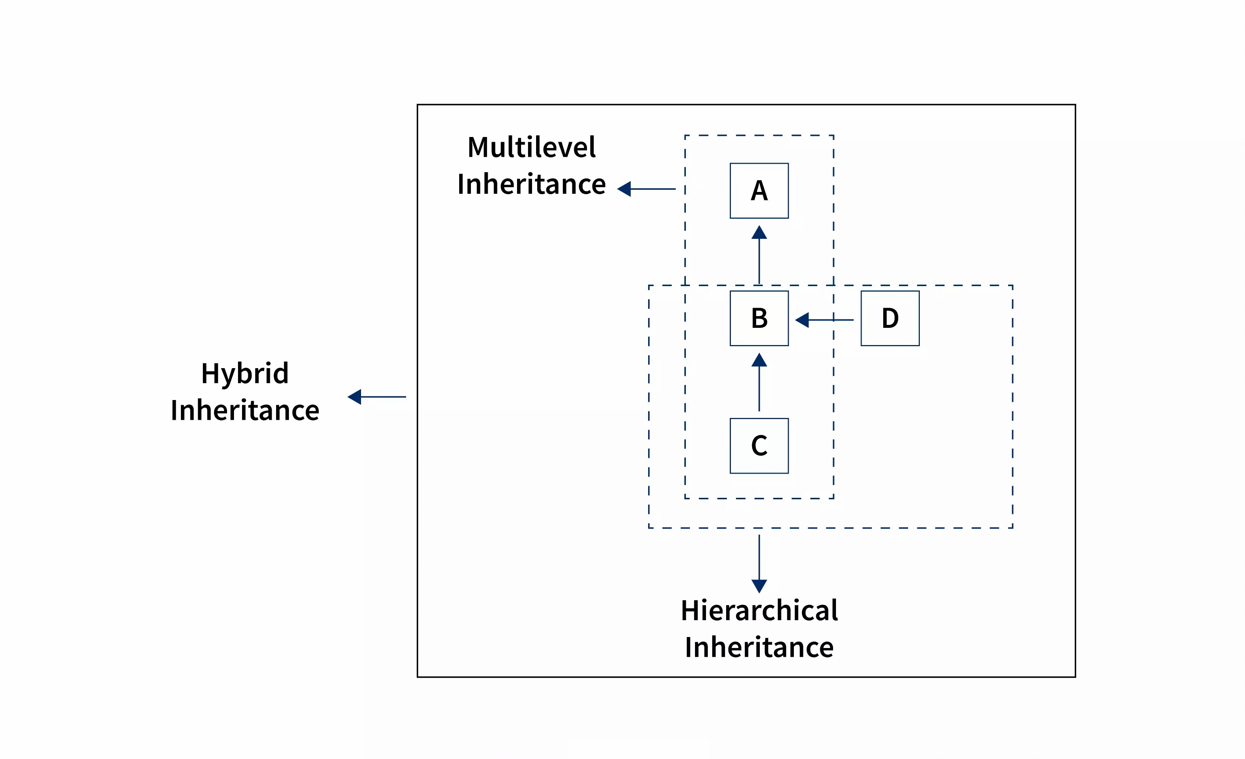
Eg: Hybrid_Inheritance_Eg2
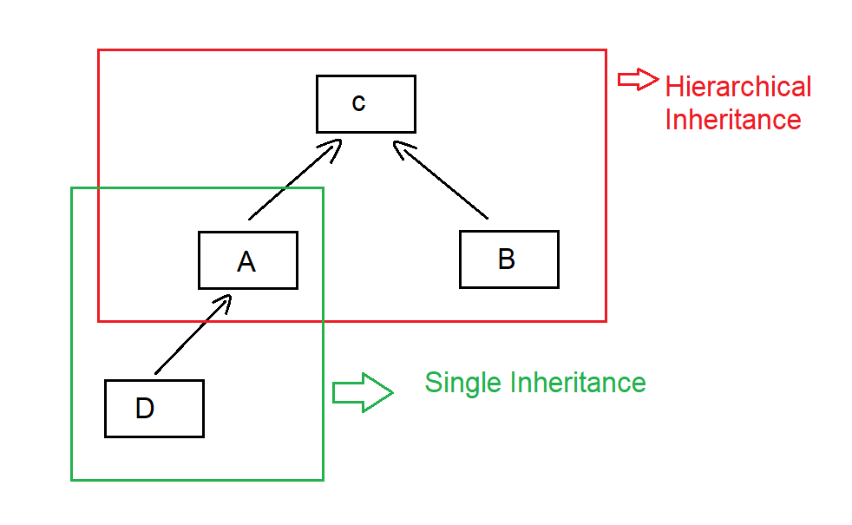
Eg: Hybrid_Inheritance_Eg3

Multiple inheritance using classes is not allowed in Java
What does multiple inheritance mean?
Multiple inheritance means:
One child class tries to extend more than one parent class
Example (❌ NOT allowed in Java):
class A {
void show() {
System.out.println("A");
}
}

class B {
void show() {
System.out.println("B");
}
}

// ❌ Java does NOT allow this
class C extends A, B {
}
Java completely blocks this syntax.

2️⃣ Reason: Ambiguity when two parent classes have the same method / variable
What is ambiguity?
Ambiguity means:
Java gets confused and cannot decide which parent’s member to use
Why does confusion happen?
Both parent classes contain the same method name:
class A {
void show() {
System.out.println("From A");
}
}

class B {
void show() {
System.out.println("From B");
}
}
Now assume Java allowed this:
class C extends A, B {
public static void main(String[] args) {
C obj = new C();
obj.show(); // ❓ Which show()?
}
}
🔴 Big Question for Java
- Should show() come from A?
- Or from B?
👉 Java cannot guess
👉 Java does not auto-pick
👉 Java forces clarity at compile time
This confusion is called ambiguity.

3️⃣ Diamond Shape Problem → Compile-time ambiguity
Now let’s see WHY it is called a Diamond Problem
Diamond-shaped inheritance diagram
A
/ \
B C
\ /
D
Code version (conceptual)
class A {
void display() {
System.out.println("A");
}
}

class B extends A {
}

class C extends A {
}

class D extends B, C { // ❌ Not allowed
}
What happens internally?
- B gets display() from A
- C gets display() from A
- Now D gets two paths to display()
A → B → D
A → C → D
🔴 Ambiguity at compile time
When D calls:
display();
Java asks:
Which path should I follow?
- Via B?
- Via C?
This confusion happens before the program runs, so it is a
👉 Compile-time ambiguity

7️⃣ Cyclic Inheritance in Java
Cyclic inheritance means:
- A class cannot be both parent and child of another class (directly or indirectly)
❌ Invalid
class A extends B {}
class B extends A {}
This causes an infinite inheritance loop, so Java blocks it at compile time.
✔️ Java compiler detects this early
✔️ This rule prevents infinite memory dependency

